Pangilinan, Bien Gabrielle M.   
WD-301 | WCSERVER

**Step-By-Step Procedure**

Express Web Server  
  
We used the file index.js with the port 3000.  
After starting the webserver and opening it in the web browser, it will present “My New App!”  
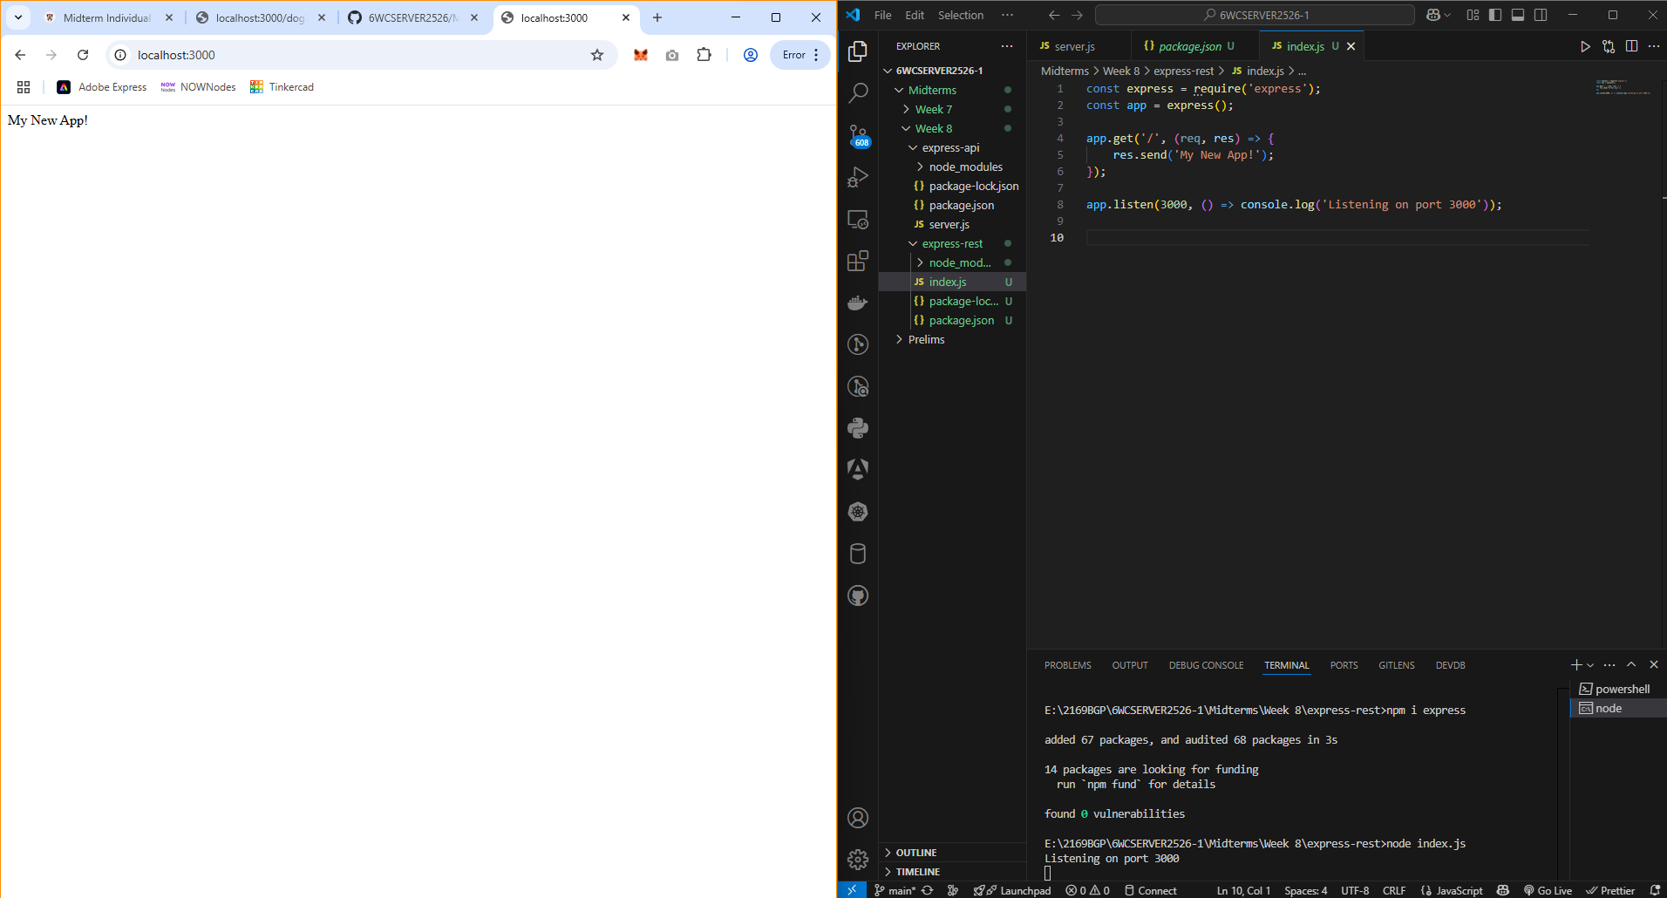

Simulating a simple API  
We are still using the file index.js and port 3000.  
But this time, we added heroes to present on the web browser.  
We added it through the use of /api/heroes on the endpoint.  
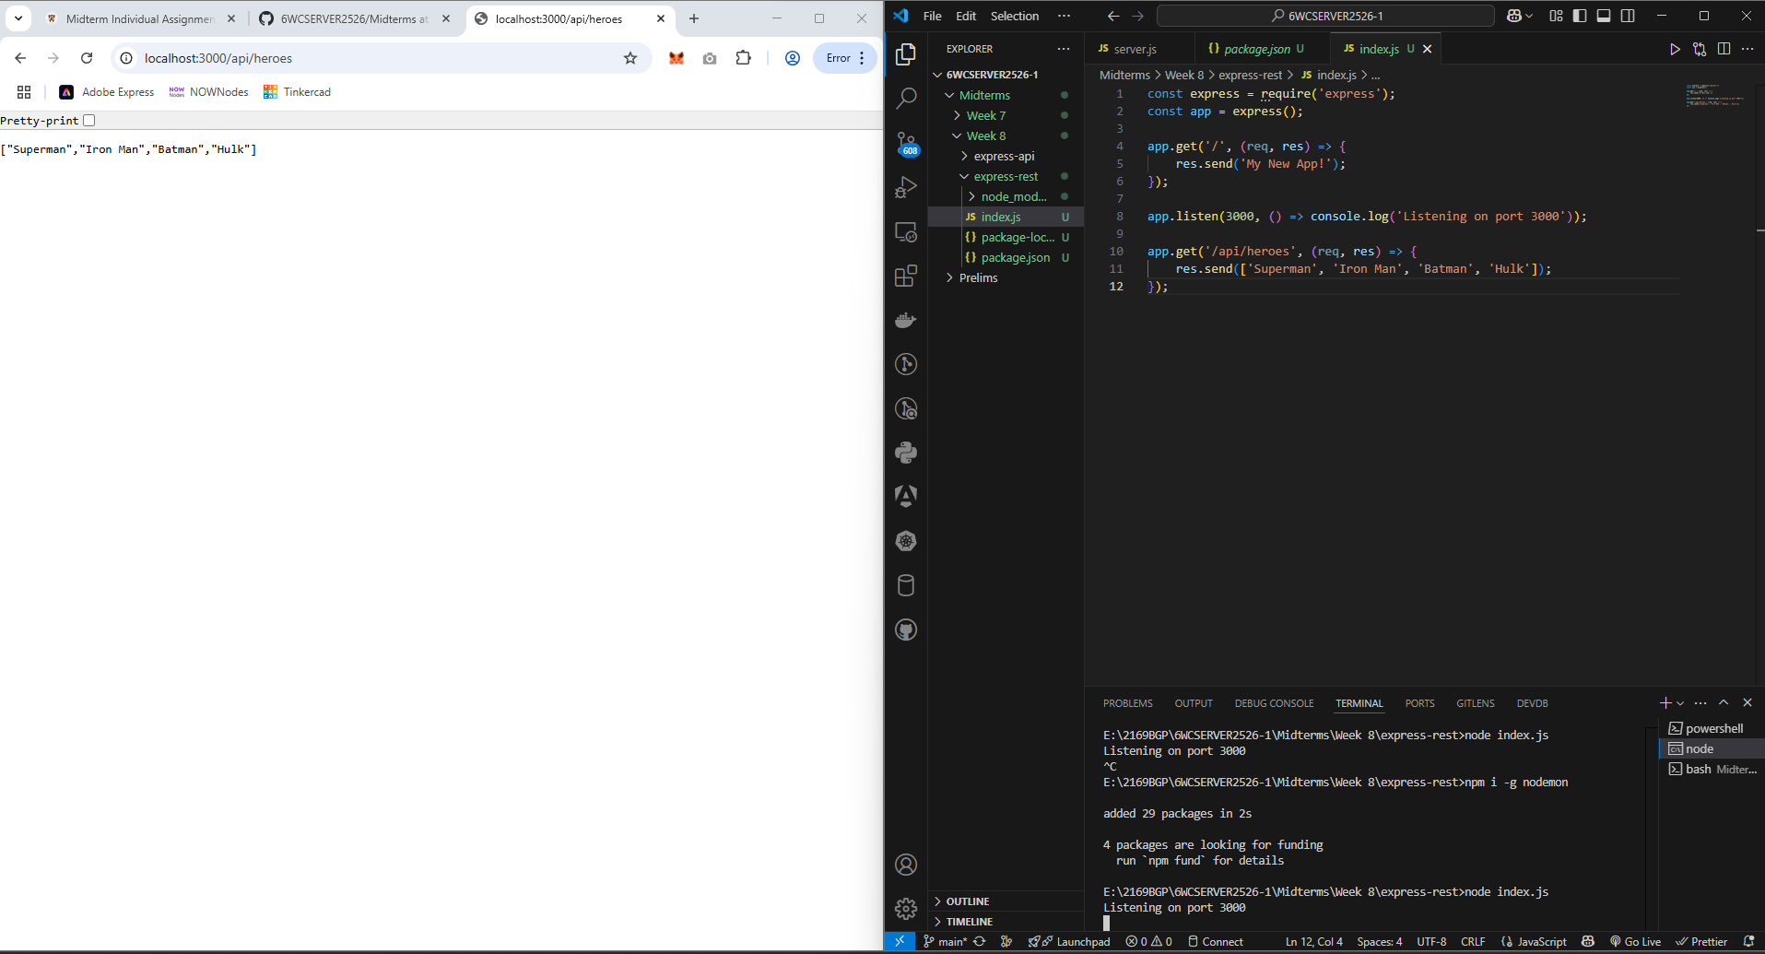

Express Route Parameters  
We are still using the file index.js and port 3000.  
This time we are including the publisher and title by using Multi params.  
For example: “http://localhost:3000/api/heroes/superman/DC”  
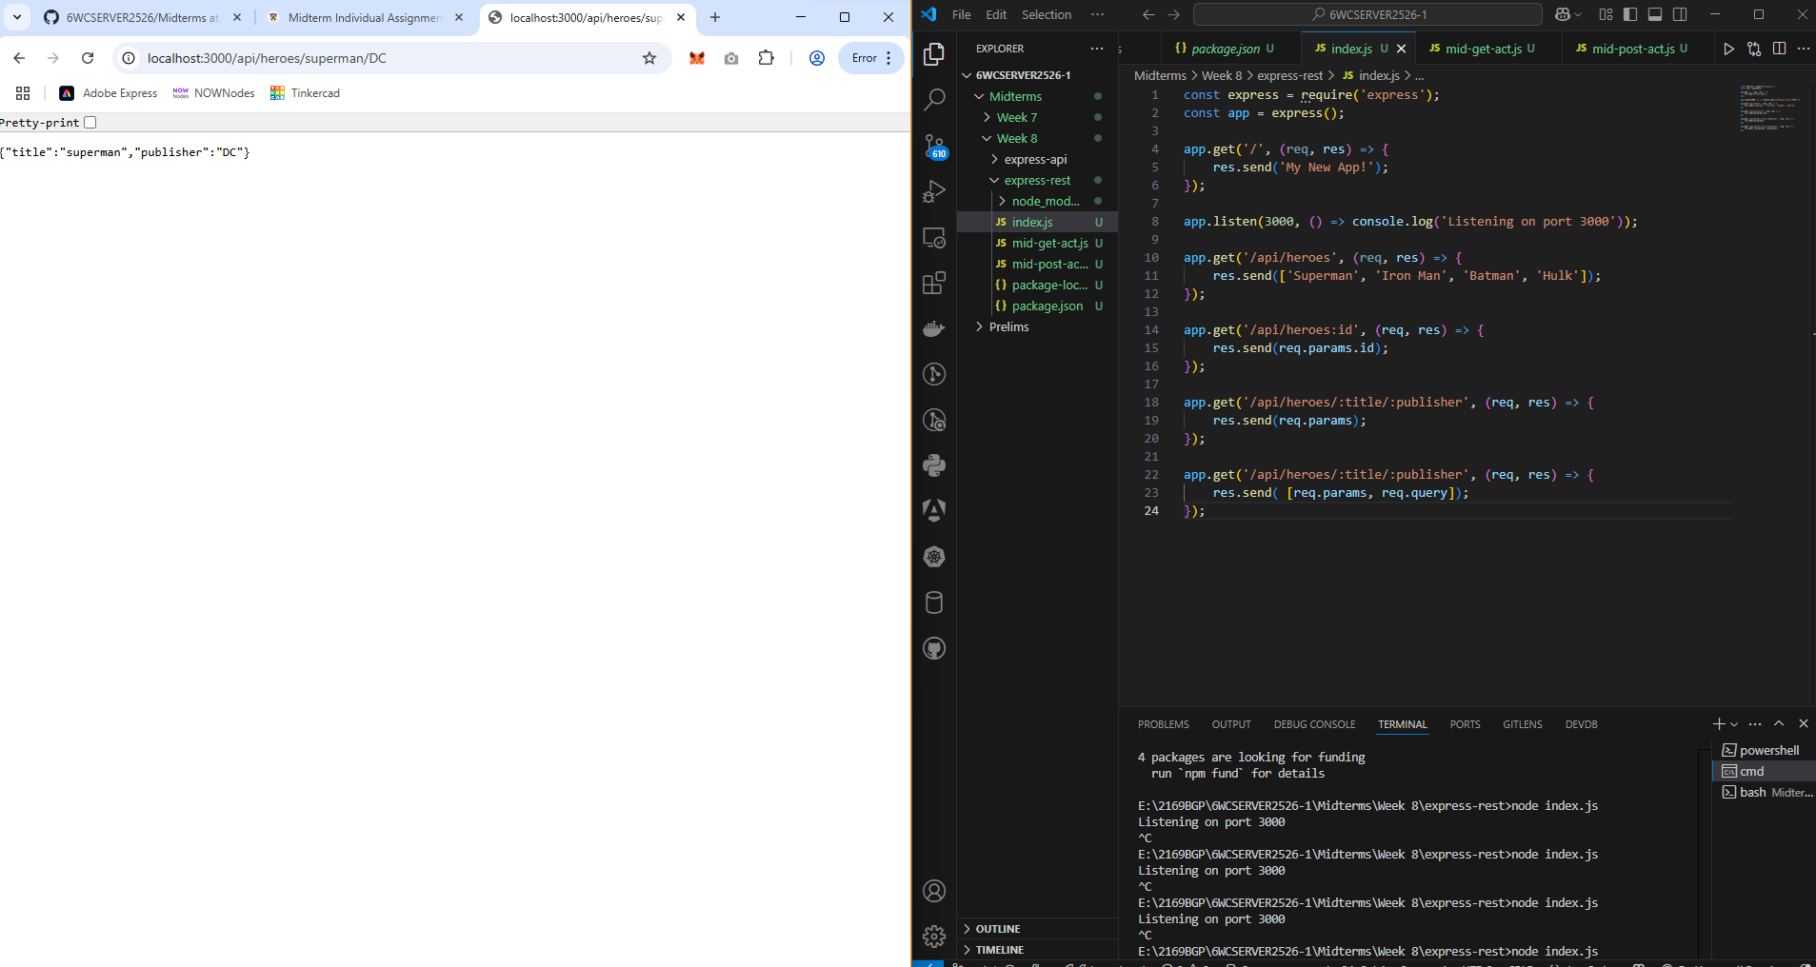  
  
  
HTTP GET Request  
We are using the file mid-get-act.js and port 4000.  
In this method, we are using an array for the GET Method.  
In Postman, the URL will present all movies, and it is possible as well to present a specific movie by using the id.  
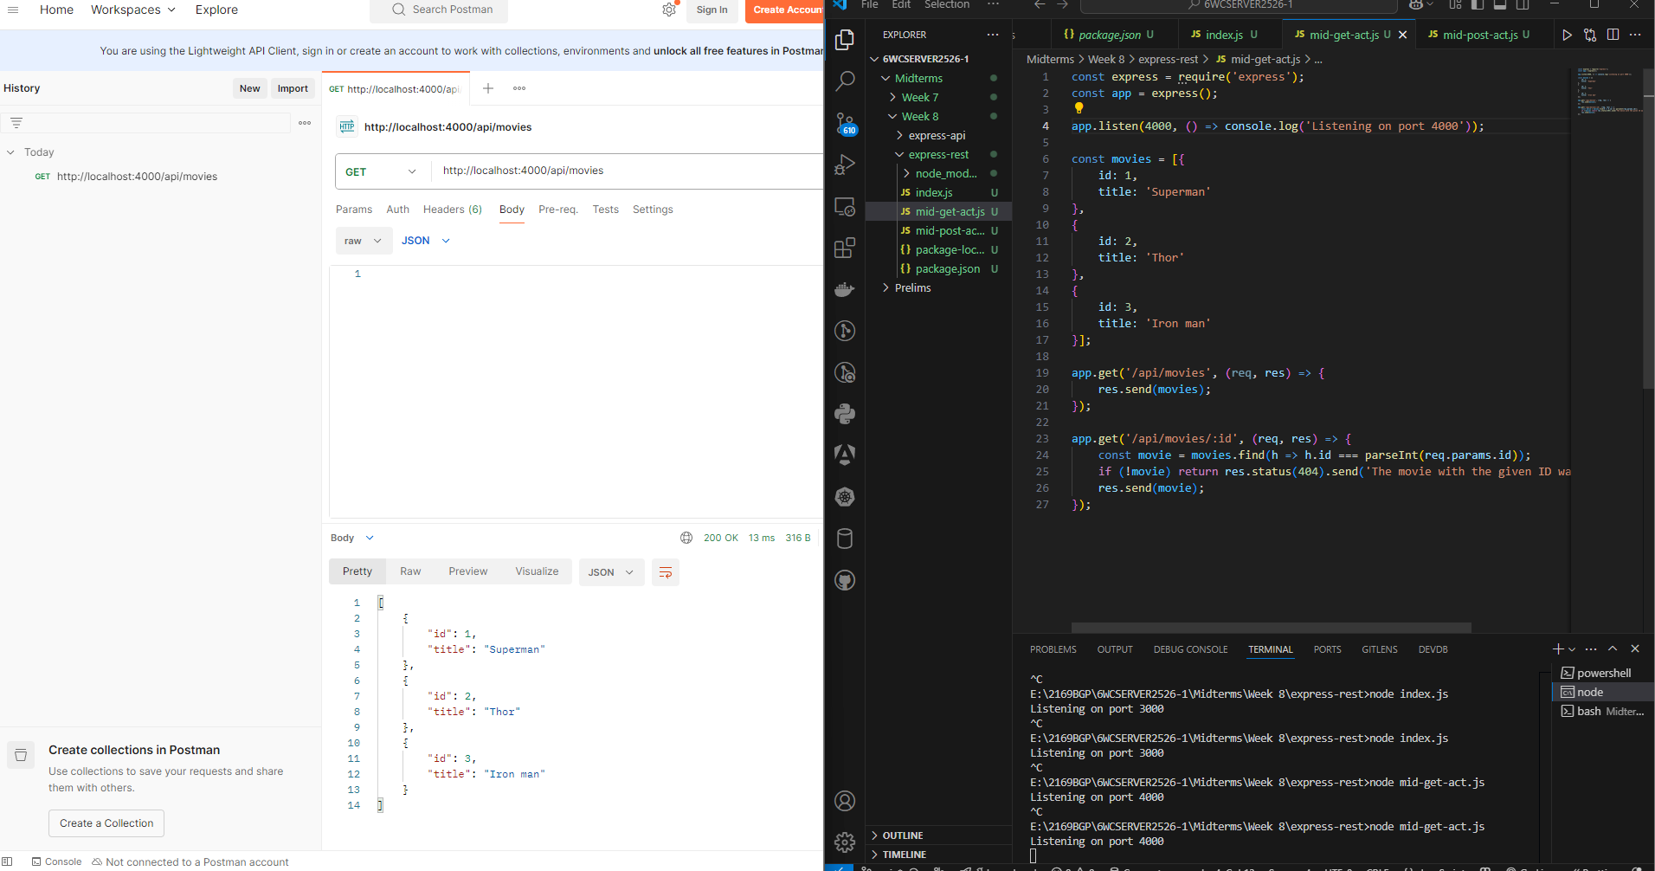

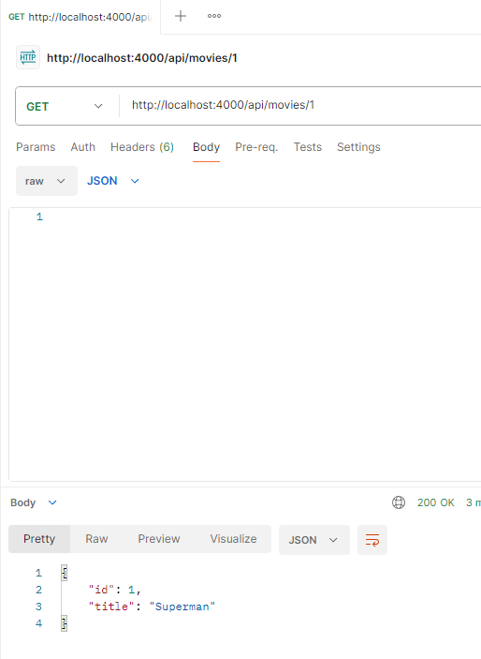

HTTP POST Request  
In the POST method, we are still using POSTMAN.  
In this method, we are simply adding movies using the POST method.  
At first I used POST to add “id: 4” as Gagamboy, and you will see in the second screenshot, when you go back to presenting using GET, the movies I added are shown.  
